Acts 27-28 – Bible Study
NB: You probably won’t have time to get through all of these questions - feel free to decide which will be most useful for your group, even thinking of your own application questions if the ones here ‘miss the mark’ for your group.
- Share one thing that has really struck you about the book of Acts.

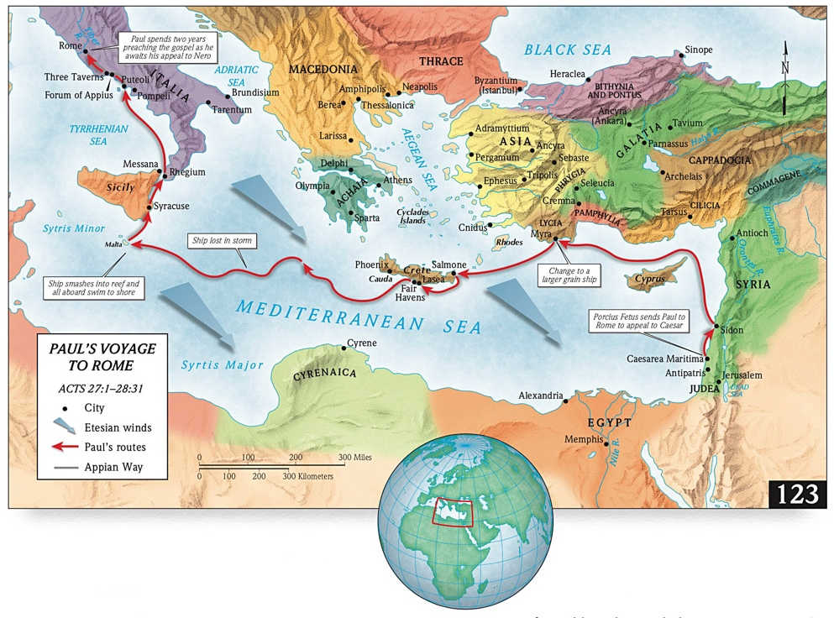
- Read Acts 27:1-20. Why was Paul’s advice in v.10 ignored? How do the sailors (and Luke) feel by the end of verse 20?
He was a prisoner, there were economic considerations (the owner’s profit), perhaps Paul was not taken seriously in anything he said.
By v20, they had all given up hope of being saved.

- Read Acts 27:21-44. Why do you think God waited till now to give this vision? Compare v.20 with 2 Cor 1:8-9. Have you ever been in complete despair and found that God was your true hope?
Perhaps to show that Paul’s word was reliable so that maybe they would take him seriously in other areas. At least those with eyes to see could have acknowledged that when all hope was gone, there was still hope – in God.

- How is Paul treated in these verses? How can you explain the difference between his original warning in v.10 (that there would be loss to lives) and v44?
Julius takes Paul’s word as true – even being prepared to cast away their only lifeboat on Paul’s command. Others find encouragement in his words.
Verse 43 shows Paul’s words as coming true. V.10 is what their actions would have resulted in, v43 is the result of God’s grace, possibly in answer to Paul’s prayers – see v24. Paul was going to survive, but God graciously spares everyone else too!

- Read Acts 28:1-16. “… and so (I.e ‘in this way’) we came to Rome.” List the things that might have prevented Paul’s arrival and (humanly speaking) the things that made it possible. Would it have been easy for Paul to trust God that he would make it to Rome (23:11, 27:24)?
Being handed over to the Jews in Jerusalem - appeal to Caesar upheld; ship being lost at sea - reaching Malta; ship wreck if sailors had abandoned ship - soldiers cutting away lifeboat; execution by soldiers - centurion sparing Paul; snake bite - no ill effects. There are always things that put pressure on faith, and it seems Paul was still afraid (27:24 Paul did not have to repeat the first 5 words the angel said!), but trust can persevere through these things, as Paul’s did.
- Read Acts 28:17-31. Why do the Jewish leaders respond in the way they do in vv21-25? Do you think Paul is disappointed by their response?
Initially they leaders want to hear Paul (v22) but end up divided over it (v24); such that he loses his audience (v25). Paul applies the prophetic judgement of Isaa to this crowd.
The mention of the Holy Spirit in v25 grounds the authority of his pronouncement - he trust’s God’s plans. Even as the Jews reject, Paul knows that this is part of God’s plan for the gospel to go to the Gentiles.
- Why are vv30-31 such a fitting conclusion to Acts? (cf. 1:8; 23:11).
This is the fulfillment of the ‘big idea’ for the apostles to take the gospel to the nations. Paul has 2 years preaching boldly and unhindered!
Additionally, it is a bit of an abrupt ending… implying that the mission is to continue in the NT church.
- In v.22 Christianity is called a ‘sect’. This most likely implies it is a branch within Judaism (see Paul in Acts 26:5). What does Paul say about this? Are there similarities with how some people today try to define Christianity (and what we must say in response?)
Christianity is the fulfilment of Old Testament faith – Law and Prophets, not a sect within it. People today try to make Biblical Christianity one faith among all faiths, but it is the one true way to relationship with God. And so people will always “talk against this”.

Think About:
- Paul’s calmness stems from God’s specific revelation to him. We don’t have such specific promises – but we do have many others in the Bible. What are some promises of God that you dwell on? How might these passages help you share Paul’s calm trust in God? (Matt 6:25-34; John 14:1-6; Roman 8:28-30; Rev 21:1-4).

- Can you look back and see God working good in your life in situations that seemed so out of control at the time?

- What do you do when you can’t make sense of a given situation?

- How have these chapters challenged you to think about God’s ongoing mission to take the gospel to the ‘end of the earth’?

Acts 27-28 – Bible Study
- Share one thing that has really struck you about the book of Acts.

- Read Acts 27:1-20. Why was Paul’s advice in v.10 ignored? How do the sailors (and Luke) feel by the end of verse 20?

- Read Acts 27:21-44. Why do you think God waited till now to give this vision? Compare v.20 with 2 Cor 1:8-9. Have you ever been in complete despair and found that God was your true hope?

- How is Paul treated in these verses? How can you explain the difference between his original warning in v.10 (that there would be loss to lives) and v44?

- Read Acts 28:1-16. “… and so (I.e ‘in this way’) we came to Rome.” List the things that might have prevented Paul’s arrival and (humanly speaking) the things that made it possible. Would it have been easy for Paul to trust God that he would make it to Rome (23:11, 27:24)?

- Read Acts 28:17-31. Why do the Jewish leaders respond in the way they do in vv21-25? Do you think Paul is disappointed by their response?

- Why are vv30-31 such a fitting conclusion to Acts? (cf. 1:8; 23:11).

- In v.22 Christianity is called a ‘sect’. This most likely implies it is a branch within Judaism (see Paul in Acts 26:5). What does Paul say about this? Are there similarities with how some people today try to define Christianity (and what we must say in response?)

Think About:
- Paul’s calmness stems from God’s specific revelation to him. We don’t have such specific promises – but we do have many others in the Bible. What are some promises of God that you dwell on? How might these passages help you share Paul’s calm trust in God? (Matt 6:25-34; John 14:1-6; Roman 8:28-30; Rev 21:1-4).

- Can you look back and see God working good in your life in situations that seemed so out of control at the time?

- What do you do when you can’t make sense of a given situation?

- How have these chapters challenged you to think about God’s ongoing mission to take the gospel to the ‘ends of the earth’?

